## ADF Standard Configurations

## Application Structure

The ADF application will have two projects as described:

|  |  |  |
| --- | --- | --- |
| **Project Name** | Objects Used | Notes |
| Model | ADF BC, Session Scope | There will be no dependencies between 2 projects, otherwise we will violate MVC. |
| ViewController | .jsf pages, Scopes, back beans, task flows, third party libraries,… |

## Application Configurations

We will configure any ADF application as described:

|  |  |  |
| --- | --- | --- |
| **Configuration** | Configured Files | Description |
| Application Session | * web.xml | Application session timeout will set to 15 minutes and it should not be more than 45 mins. |
| MDS | * web.xml * adf-config.xml | You can apply MDS to ADF application. MDS changes will be stored in database using RCU. |
| Shared Template and CSS | * weblogic.xml * trinidad-config.xml * trinidad-skins.xml | You can create a separate application for template, images and CSS, then we will generate jar file from this application and we will use this jar file in the ADF application.  This jar file will be deployed in the weblogic as a shared library and ADF application will reference to it using library-ref in weblogic.xml. |

## 

## Model Configurations

These some configurations we will apply in the Model Project

|  |  |
| --- | --- |
| **Configurations** | Description |
| AppModule | * In AppModule tuning you can tick on “ Customize Runtime Instantiation Behavior” and select “Lazy Loading”      * In bc4j.xcfg we will set Application Pool as following: * Initial Pool Size (number of AM instances created on first ever access, recommended to be 10% more than estimated number of concurrent users). * Maximum Pool Size (number of maximum AM instances pool can create, recommended to be 20%-30% more than initial pool size). * Referenced Pool Size (number of active AM instances, recommended to be the same as estimated number of concurrent users – to avoid frequent passivation/activation). * Minimum Available Size = 5 (when set to 0, allows to release all AM instances after an idle timeout, this helps to release reserved database connections as well. Is set to 0 for tests in stress environment, in your system you may set it to a higher value, but less than referenced pool size). * Maximum Available Size = 25 (maximum number of AM instances after pool clean-up). * Idle Instance Timeout = 600 (AM instance is considered inactive after 10 minutes of inactivity, this if for the stress test. In your system, you would set it something close to Web session timeout – to prevent frequent passivation/activation). * Pool Pooling Interval = 600 (AM pool is cleaned every 10 minutes). * If the customer want the ADF application session timeout to be more than 1 hour, set this configurations in AM   jbo.ampool.maxinactiveage=18000000 (5 hours)  jbo.ampool.timetolive=-1  jbo.doconnectionpooling=true  jbo.txn.disconnect_level = 1 |
| ViewObjects | For all VOs you can tick on “Include All Transient Values”    Set key attribute for all VOs even it is programmatic VO |

## 

## View Controller Configurations

|  |  |
| --- | --- |
| **Configurations** | Description |
| Template | You can use AltaUI Responsive Template. |
| Task flows | By default, we will not use regions (.jsff), but if we find something reusable we can use it. |
| Your code library | We have created our own library has the common code used in any ADF application. We generate jar file for this library and we will use it in ADF application. This library will deployed in weblogic as a shared library and we will reference it in weblogic.xml file. |

## Application Deployment

* In ADF application you can create war file in the ViewController project.
* In war file option we set context root and un-check any shared library under WEB-INF/lib 🡪 Filters.
* In Application level we create Ear file, and from Application Assembly we will select the war file.
* In Deployment: Weblogic we untick “Auto Generate and Synchronize Weblogic JDBC…” The setting will be like this:

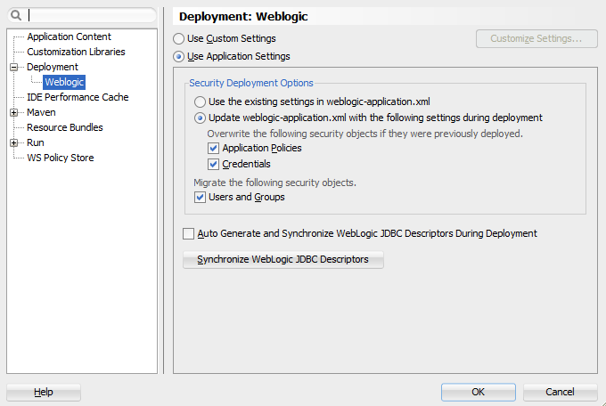

* From application menu 🡪 Deploy 🡪 Deploy to Ear file
* Open Weblogic console or Enterprise Manager (EM) and deploy ear file or use side by side deployment.

### Data Source

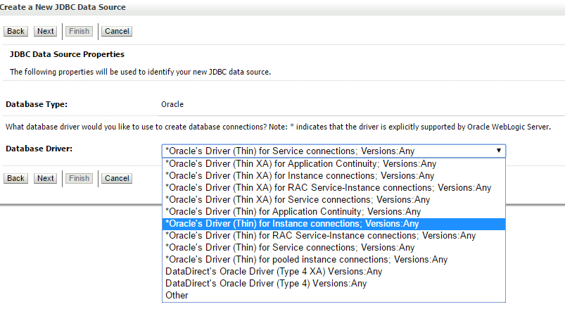

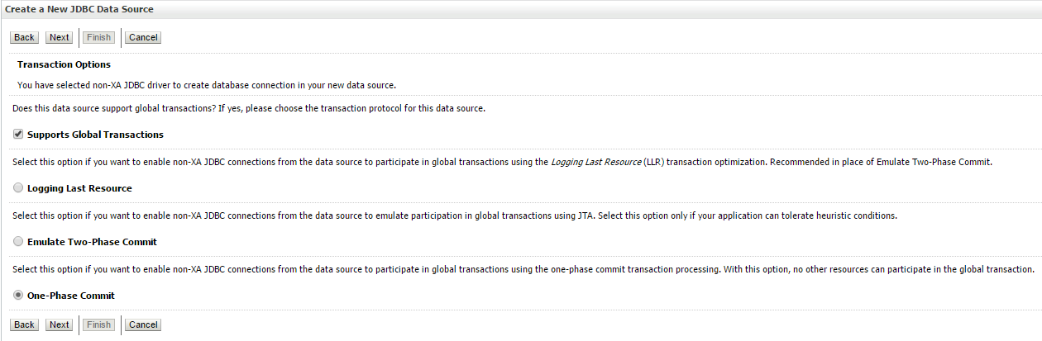

* After creating the data source, we increase “Maximum Capacity” to be 100.

